|  |  |
| --- | --- |
| NAME | PLASMADONATION |
| TEAM ID | PNT2022TMID26437 |
| MARK | 4MARK |

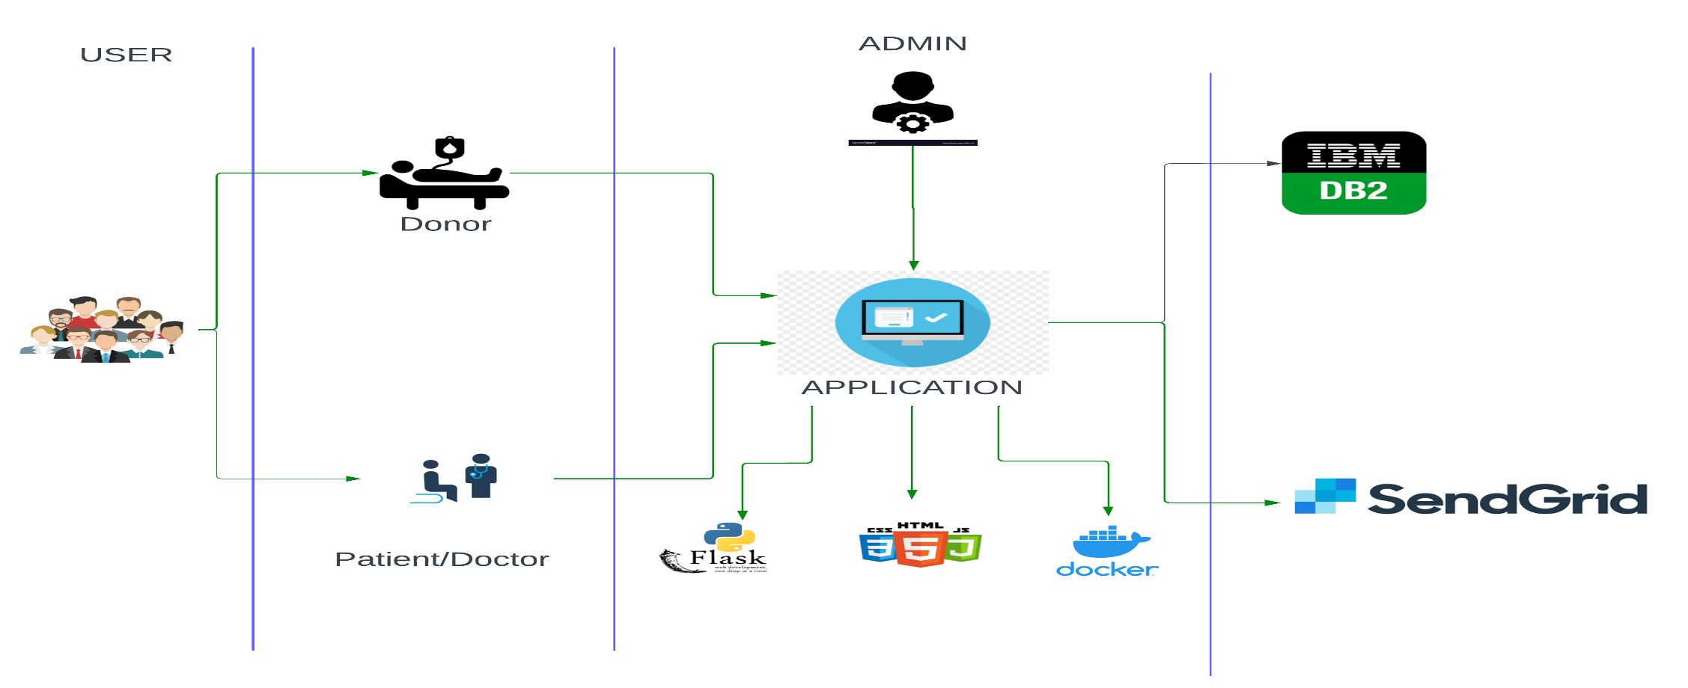

**Table-1: Components & Technologies**:

|  |  |  |  |
| --- | --- | --- | --- |
| SNO | Component Description | Description | Technology |
| 1 | User Interface | The interaction between the user and application  e.g.,Web UI, Mobile App, Chatbot etc | HTML, CSS, JavaScript / Bootstrap etc. |
| 2 | Application Logic-1 | Framework used for design the application. | Python, Python - Flask |
| 3 | Application Logic-2 | Accessing the cloud and storing the details of the users both donors and patients. | IBM Cloud, IBM DB2 |
| 4 | Application Logic-3 | Docker is an open-source platform for building, deploying, and managing containerized applications. | Docker |
| 5 | Database | Data Type, Configurations etc. | SQL. |
| 6 | Cloud Database | Database Service on Cloud | BM Cloudant, IBM DB2 etc. |
| 7 | File Storage | File storage requirements | IBM Block Storage or Other StorageService or Local Filesystem |

**Table-2: Application Characteristics:**

|  |  |  |  |
| --- | --- | --- | --- |
| sno | Characteristics | Description | Technology |
| 1 | Open-Source Frameworks | Python – flask is an open-source framework used to develop the application. | Python – flask is an open-source framework used to develop the application. |
| 2 | Security Implementations | Container registry and Kubernetes Cluster are used for encryption of data. | Container registry and Kubernetes Cluster |
| 3 | Scalable Architecture | Kubernetes Cluster allow containers to run across multiple machines and environments. | Kubernetes Cluster |
| 4 | Availability | Kubernetes Cluster provides all time availability. | Kubernetes Cluster |
| 5 | Performance | Docker improves the application performance. | Docker |